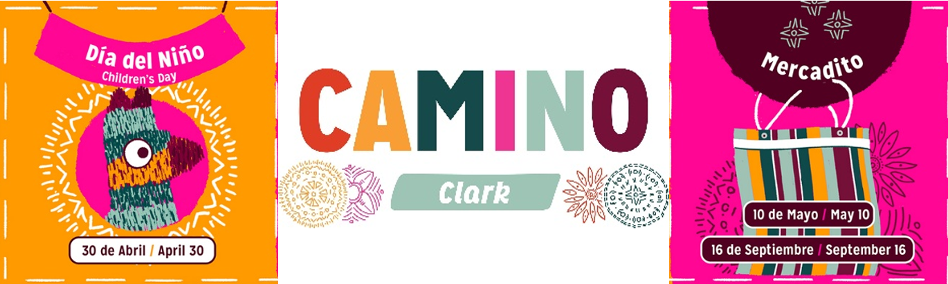

For Immediate Release Press Contact: Maggie Sullivan
Images available for download here >> 708-860-9299/maggie@silvermangroupchicago.com

Rogers Park Business Alliance announces spring events within the State-Designated Mexican Cultural District Camino Clark

Community events celebrate the rich Mexican culture of the Cultural District, from local artisan markets to traditional Mexican holiday celebrations

CHICAGO (March 25, 2026) – The nonprofit Rogers Park Business Alliance (RPBA) is proud to announce the lineup of spring events within the State-Designated Mexican Cultural District, Camino Clark, to celebrate the unique cultural identity of Clark Street in Rogers Park and encourage economic development. The spring events include a Día del Niño (Children’s Day) Celebration on April 30, a Cinco de Mayo Celebration on May 5, and a Mother’s Day Mercadito craft fair on May 10. More information about the cultural district and events is available at RPBA.org.

The Camino Clark area, which spans approximately two miles from Howard Street to Devon Avenue, was one of ten communities selected for the State-Designated Cultural Districts program and the only one on Chicago’s North Side. State-Designated Cultural Districts are communities, towns, or specific geographic areas with a distinct shared historical and cultural identity that binds them together. Additionally, Colectivo Clark, a collective of local Latine business owners within the Camino Clark area, was formed to organize events and promotional campaigns to celebrate the District and empower small business owners.

The Camino Clark Cultural District programming in Spring 2026 includes the following events:

Día del Niño Celebration
Thursday, April 30, 4 p.m.-7 p.m.
St. Jerome Church, 1709 W. Lunt Ave.
Free to attend
Every year on April 30th, Mexico celebrates Día del Niño (Children’s Day), a cultural tradition dedicated to children and the creativity of childhood. Families are invited to stop by St. Jerome Church and partake in creative, interactive activities. In addition, businesses along Camino Clark will offer kids a fun way to connect with their business through hands-on activities such as piñata making, arts and crafts, with giveaways of special treats and surprises along the way.

Cinco de Mayo Celebration
Tuesday, May 5
Various businesses along Clark St.
Prices determined by businesses
Cinco de Mayo is a day that celebrates Mexican heritage, resilience, and cultural pride, commemorating the Mexican army’s victory over French forces in 1862. On May 5, many Mexican and Latine-owned businesses in Camino Clark that help define the corridor will have special promotions, menu items, and offers for Chicagoans to explore throughout the district. Participating businesses will also receive a visible storefront identifier as a celebratory marker to signal their involvement and help create a vibrant, corridor-wide Cinco de Mayo experience within Camino Clark.

May Mercadito
Saturday, May 10, 10 a.m.-3 p.m.
GROW/PROGRESANDO entrepreneurial training center, 7056 N Clark St.
Free to attend
Mercadito is organized twice a year by the Rogers Park Business Alliance. It features small, local entrepreneurs and independent creators who offer unique, handcrafted goods that aren't typically available in large retail stores. The goal of Mercadito is to allow entrepreneurs with a business idea to test the market in the Rogers Park community while also featuring products that reflect the unique culture, traditions, and creativity of the area. It aims to help preserve the Camino Clark cultural heritage while promoting diversity and creative expression.
About Rogers Park Business Alliance
Rogers Park Business Alliance is a nonprofit organization that has served Chicago’s diverse Rogers Park neighborhood for over 30 years, providing services in both English and Spanish to a broad community. RPBA works to cultivate and sustain a thriving economic environment in Rogers Park, serving businesses and residents with a variety of public events and business initiatives. RPBA programs include the GROW/PROGRESANDO entrepreneurial training program, the Illinois Small Business Development Center at RPBA, annual Best of Rogers Park awards, Taco Crawl, Chalk Howard Street, and the Glenwood Sunday Market farmers market—Hablamos español. For more information, visit RPBA.org.

###

